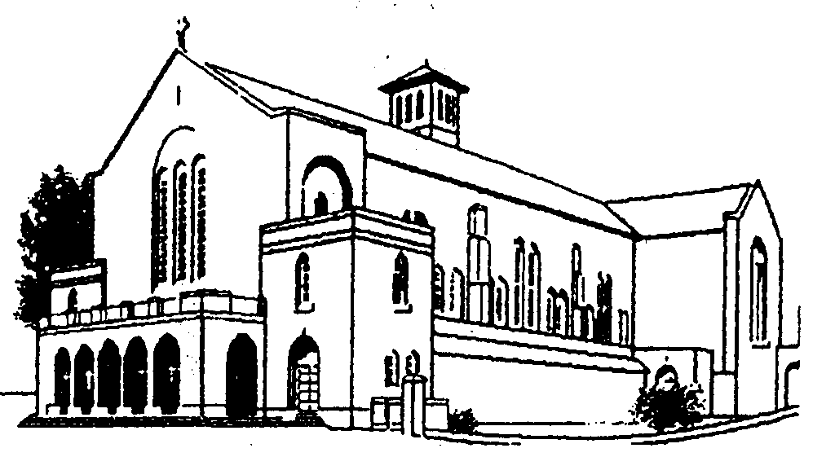
St Joseph’s Parish
East Wall – North Strand

Sacristy 01-856 0980

Email: stjosephparish1941@gmail.com

Request for Baptism
An original birth Certificate must accompany this form.
We will make a copy and return the original to you.

Child’s Surname ____________________________________________ (as on Birth Certificate)
Child’s Christian Name(s) _________________________________________________________
Date of Birth: ___________________________________________________________________
Address of Parents: _______________________________________________________________
Date and Place of Church Marriage of Parents ________________________________________________________________________________
Mother Father
Maiden name__________________________ Surname______________________________
Christian name________________________ Christian Name _______________________
Religion: † _____________________________ Religion:† _____________________________
Tel: _________________________________ Tel: __________________________________
Email: ________________________________ email: ________________________________

Godmother * Godfather *
Name: ________________________________ Name:________________________________
Is she over 16 years? ____________________ Is he over 16 years?_____________________
Is she a baptised Catholic who has been Is he a baptised Catholic who has been
confirmed? ___________________________ confirmed? ____________________________

We request Baptism for our child: **

_____________________________________ ______________________________________
Signature of Mother Signature of Father

† One of the parents must be a Catholic

*Minimum requirement is one Godparent. If there are two they must be male and female and must both be practising Catholics. Godparents must be over 16 years of age and have been confirmed.

**Signature of one parent suffices in the case of a single parent who is sole guardian.

See over ….

Official
Birth Certificate presented _____________________________________________ [ ]

____________________________________________ _______________________
Signature of Priest Date

Consent
As part of welcoming the newly baptised into our parish community, we would like your permission to do the following:
- Publish his/her name in the parish newsletter which will be available in the church and on our parish website [ ]
- To publish his/her name on the parish Facebook page [ ]
- To let you know about future events/celebrations taking place in our parish [ ]

Signed : _________________________________________ Date ____________________

Date of Preparation Meeting : ________________________________________________

Parents and Godparents of the Children to be baptised are invited to the Baptism Preparation Meeting. Because of the importance of this Sacrament of Baptism, it is highly desirable for both Parents and Godparents to attend.
Final confirmation of the Baptism of a child will take place at the Baptism Preparation Meeting.

The information contained in this form will be used to register the Baptism in the Parish.

The copy of the Birth Certificate you submitted will be destroyed once the Baptism is registered. The information entered in the Baptism Register will be retained permanently.

